AERO1005 MATLAB Coursework 2

Author: Mingqi LIU
Student ID: 20719335
Date of report: 2026/5/6

Task 1
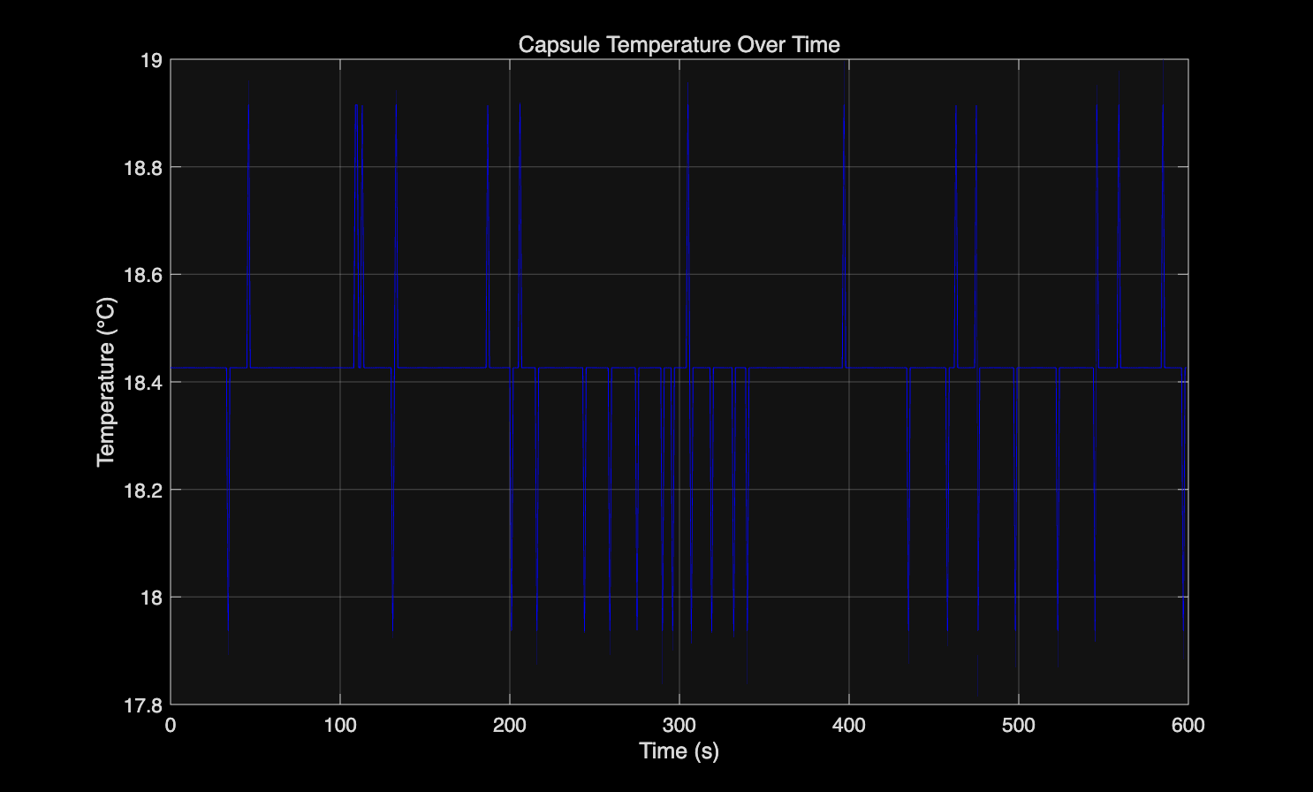
Figure 1. temperature plot
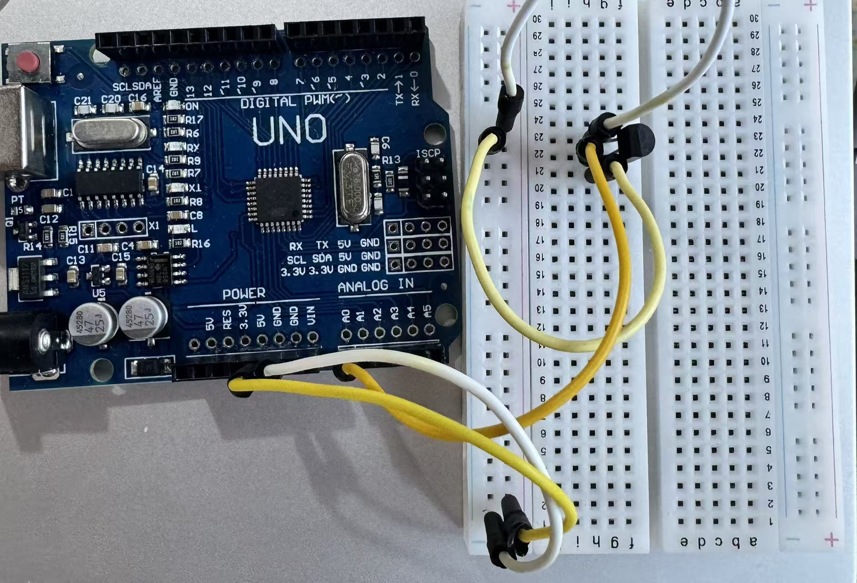
Figure 2. Temperature sensor circuit

Task2
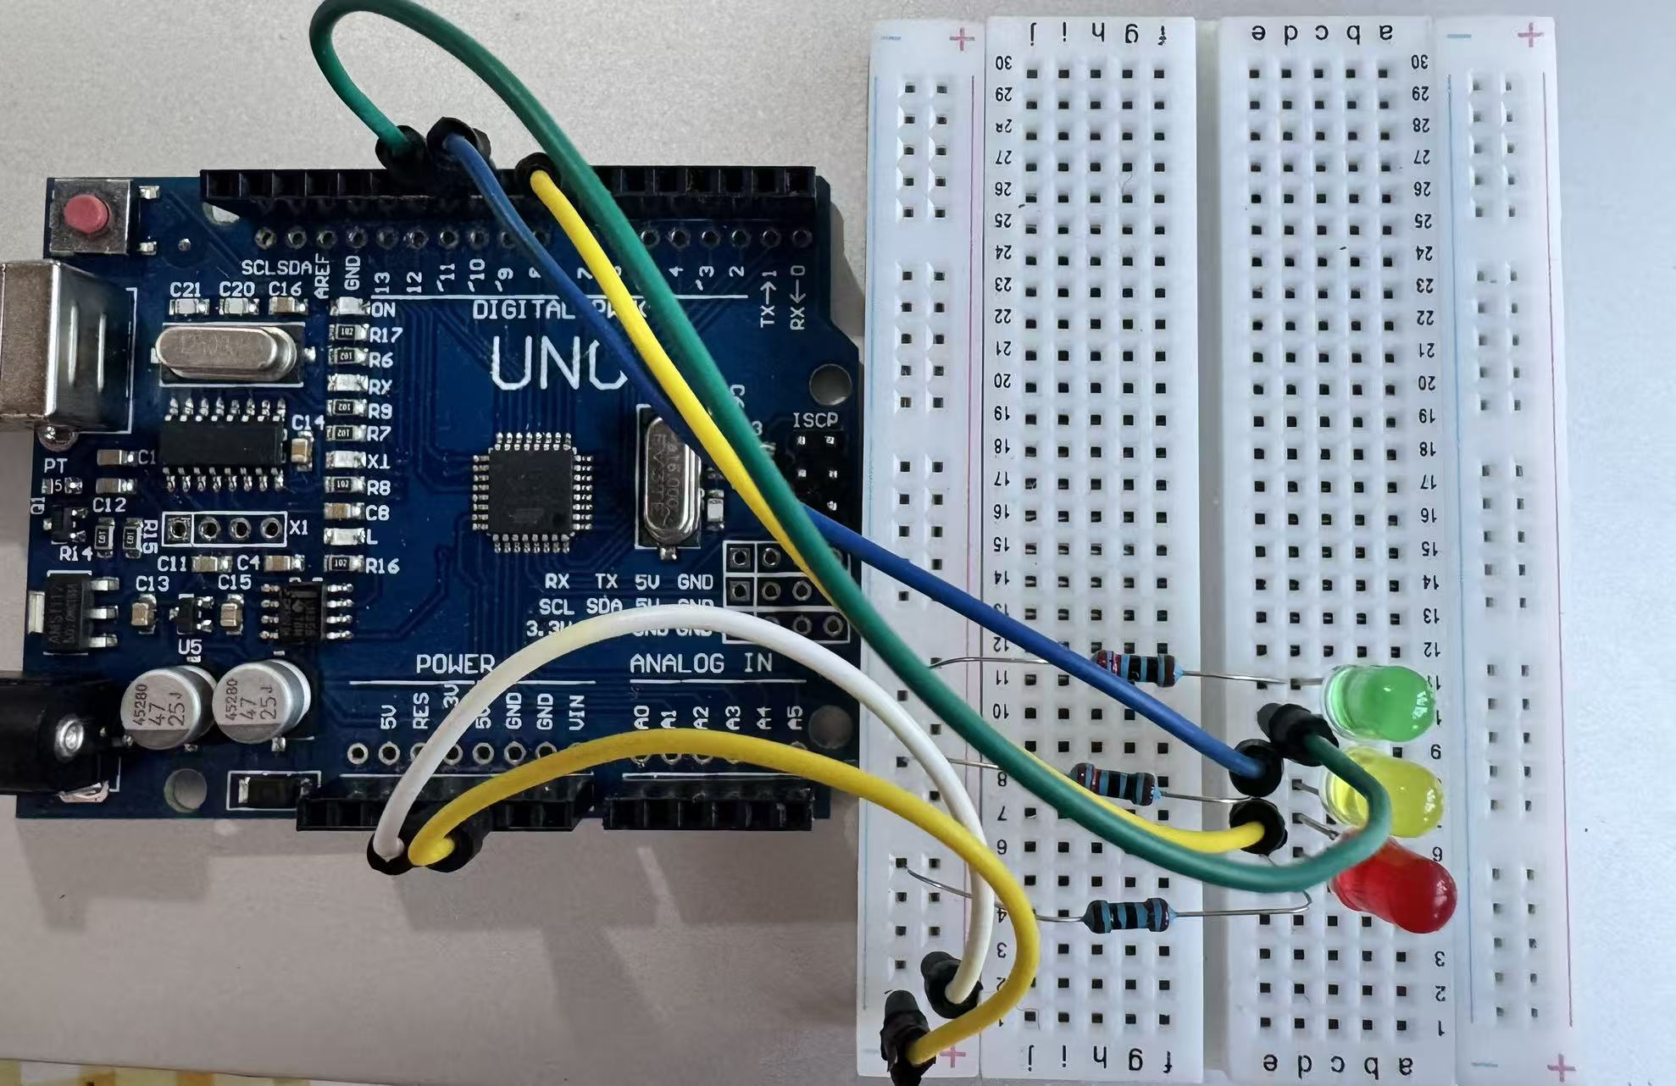
Figure 3. LED indicator circuit
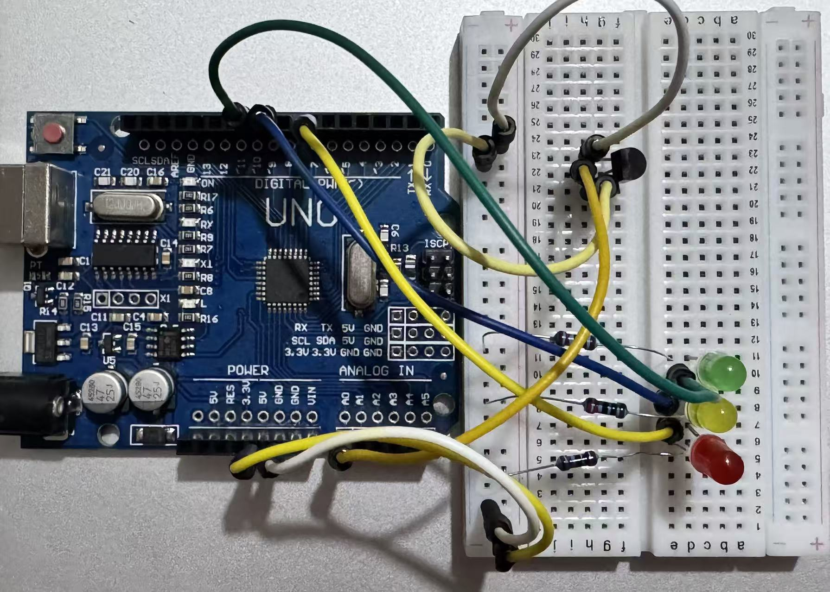
Figure 4. Complete circuit
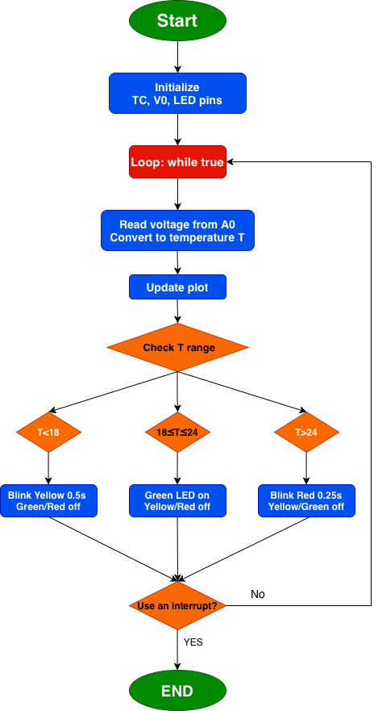
Figure 5. Flowchart 1
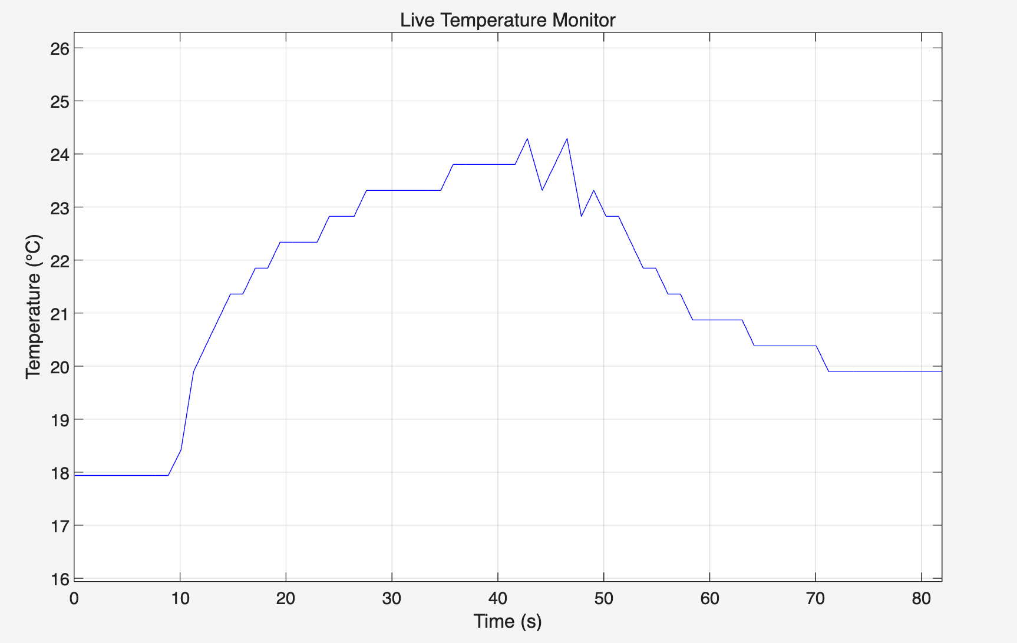
Figure 6. Live temperature monitor
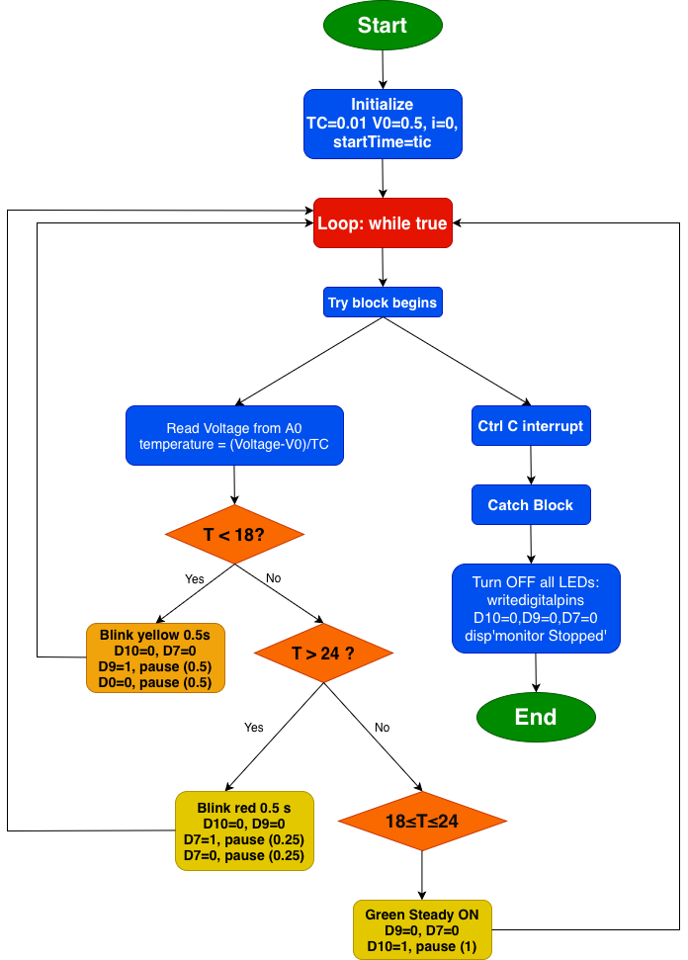
Figure 7. Flowchart 2

Task 3
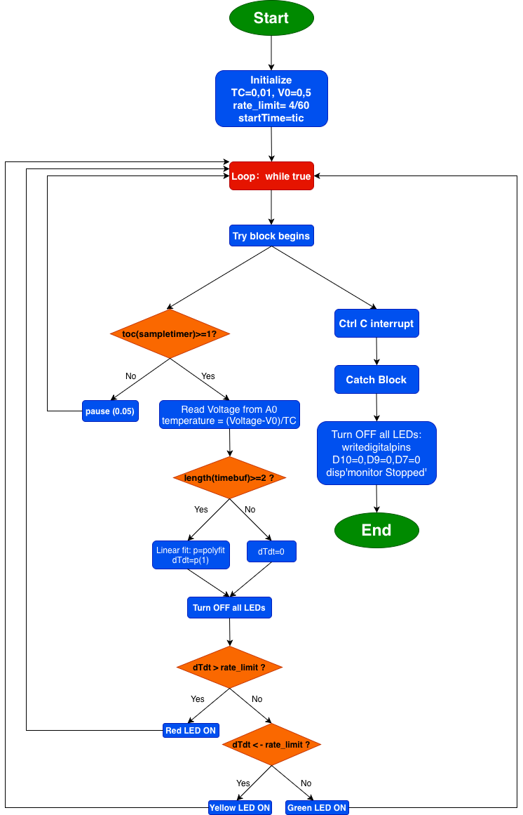
Figure 8. Flowchart 3

Task 4
Reflective Statement
The biggest challenge I encountered in this coursework was coordinating LED blinking with 1-second temperature sampling in Task 2. Initially, I used long-pause statements within a single loop, which prevented the yellow and red LEDs from blinking independently at their required 0.5-second and 0.25-second intervals. After several unsuccessful attempts, I realised that I could run the main loop at a high frequency (every 0.05 seconds) and use tic and toc to manage separate timers for sampling, yellow LED blinking, and red LED blinking. I was pleased when the LEDs operated correctly without disrupting the sampling rate.
Another major difficulty was that pressing Ctrl+C during Task 2 terminated the entire script, preventing progression to Task 3. I resolved this by wrapping the call to temp_monitor in a try-catch structure in the main script, which captured the interrupt and allowed the program to continue.
The final code demonstrates several strengths. Monitoring and prediction are separated into well-documented functions, which simplifies debugging. The sliding-window linear fit in Task 3 effectively reduces short-term noise and provides a more reliable rate of change than a basic point-to-point calculation. I also used Git version control with regular commits, which allowed me to recover my work after accidentally corrupting a working version.
However, the system has limitations. The prediction method simply extrapolates the current gradient over 300 seconds, which becomes inaccurate if the temperature trend changes. Timing relies on a pause (0.05) and is not true real-time. The system uses only one sensor and does not store data for post-analysis. In addition, Ctrl+C sometimes leaves the plot window in an unresponsive state.
With further development, I would implement a more adaptive prediction method, such as exponential smoothing to track changing trends. I would also log prediction data to a file for validation. Offloading LED control to Arduino hardware timers would improve timing accuracy.

